Timothy Castillo

11-25-2014

Scalable Data Infrastructures WPF-O

Problem Solving

**A Cat, a Parrot, and a Bag of See**

The man needs to transport each of these items – a cat, a parrot, and a bag of seed from one river bank to the other in a boat that can only hold him and one of these things at a time.

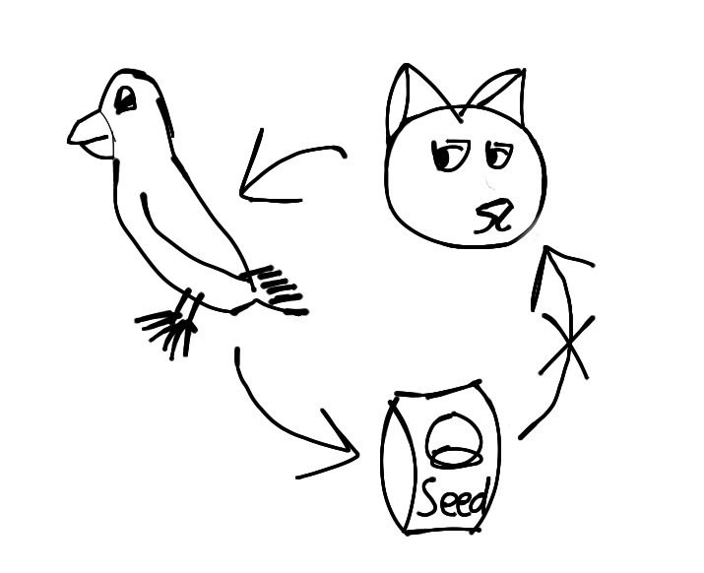

**The Problem:**

If they are left on their own, the cat will eat the parrot, and the parrot will eat the seed. So even if the man took the parrot with him first, and came back for the cat or the seed, he would seemingly need to leave either the seed or the cat with the parrot in order to have room for the last item. Or would he?

**Constraints:**

1. The cat wants to eat the parrot.
2. The parrot wants to eat the seed.
3. The Boat can only hold the man and one other item.

**Sub-Goals:**

1. Deliver each item to the other side of the river safely, and with each intact.
2. Do not over-fill the boat, causing it capsize or sink.
3. Complete the task as efficiently as possible.

**Potential Solutions:**

1. **Take each item to a separate location along the opposite bank.** This solution may keep each item safe and intact, however with a long distance between the items it will be harder to keep good track of them. It is also not the most efficient as it requires longer travel along either the opposite bank or in the boat on the river to ensure the safety of the items. Therefore it may not fulfill all of the sub-goals.
2. **Take each item on the boat at once.** This solution might work to improve efficiency, but it is more likely that the boat could capsize, thus putting the man and items in danger.
3. **Take the parrot across first and drop of the parrot. Come back for the cat and deliver the cat to the other side. Pick up the parrot and take the parrot back to the first side. Drop off the parrot, pick up the seed, and deliver it to the other side with the cat. Come back for the parrot, and deliver it to the other side with the cat and the seed.** This solution does have one more trip than the first solution, but it allows for better tracking of the items, and less over-all travel as the trip is straight across instead of up and downstream.

**Chosen Solution:**

I decided to go with solution #2, as it solves the problem while also fulfilling each of the sub-goals. This solution keeps the items in more manageable locations and distances for the man, and the path to travel is shorter, so although there is one more trip than the first solution, the trips are shorter, so all three sub-goals are met, in the animals and seed are kept safe, the boat does not become over loaded, and the task is performed in an efficient manner.

**Socks In the Dark**

**Problem:**

There are 20 socks in a drawer, and as illustrated in the picture, there are 5 pairs of black socks, 3 pairs of brown socks, and 2 pairs of white socks. If I select socks in the dark, what is the minimum needed to fulfill the following conditions?

1. At least one matching pair.
2. At least one matching pair of each color.

**Constraints:**

1. Fumbling around in the dark makes it a bit difficult to see any colors.
2. It is assumed that they are all the same texture and length.
3. It won’t be known what socks I have exactly until after I’ve selected them all.

**Sub-Goals:**

1. Have at least one matching pair.
2. Have at least one matching pair of each color.

**Potential Solutions:**

1. Sub-goal A requires at least four socks.
2. Sub-goal B requires at least 18 socks.

**Chosen Solution:**

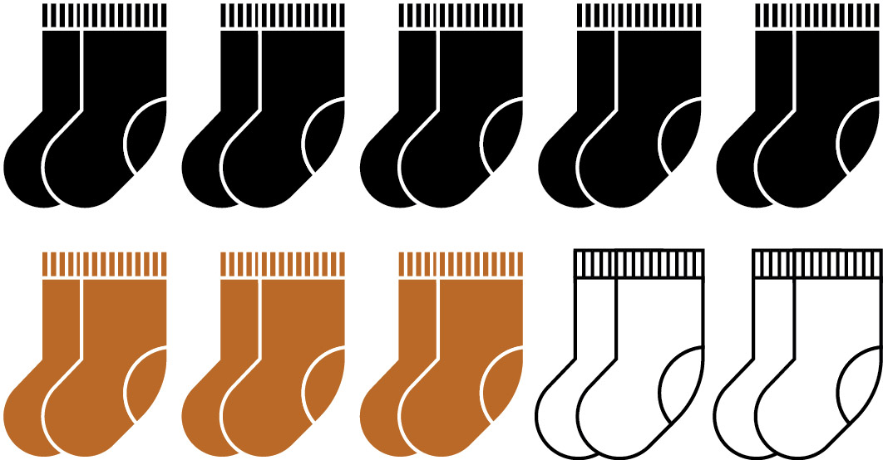I choose solution #2 for this problem, as it fulfills both goals. It is a large amount of sock, however, to ensure that every color has a matching pair, I need to eliminate the potential that I only get one sock of one color. By leaving only two socks, this makes certain that at least two white socks are left over. Any more socks left would allow for the possibility that three white socks are left behind, and one white or fewer to be taken with the brown and black socks.